**Print in color with the M3D Quad Fusion**

Written by ketterrm and Kyle 23May2019 – originally created May 2018.

Cura with the Illuminati plugin makes color printing simple! We are going to make it possible to assign different colors to each of your color your .stl files.

**Prerequisite:**

1. Go to <https://github.com/ketterrm/Illuminati-Mixer> . Click on the download button and down load the zip. Extract the zip.
2. Check that you have the latest firmware from M3D for the Quad Crane printer. Specifically check that the files \sys\print_start.g and \sys\print_end.g exist on the SD CARD of the printer which was only available as of April 2019. If not, download the latest SD card from M3D at <https://github.com/PrintM3D/Crane> by clicking on the button “Clone or Download .ZIP” and select to “download ZIP”. Extract the .ZIP data by right clicking on the downloaded file. The files can be found in the Crane-dev\SD Card Structure\Quad\sys folder to copy to the SD Card.

**Step 1: Set up Cura’s Machine setting so Cura knows that you want 8 colors!**

1. If you do not yet have the free Cura software, Download and install Cura 4.0 at <https://ultimaker.com/en/products/ultimaker-cura-software> . Many resources are also available here for training on how to use Cura.

Once installed open Cura.

From Pull Down menus, Select File -> Open File(s)….

Select “CFFFP_Quad_Illuminati_MAY2019.3mf” available from the github download for the Illuminati-Mixer.

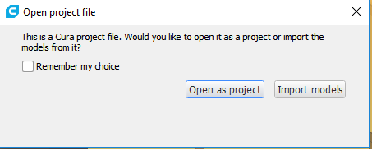

Select “Open as project” to load all the printer and configuration settings.

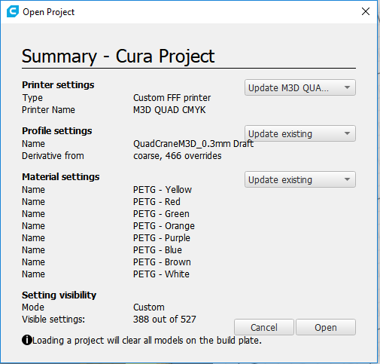

Select Open.

This will update printer settings, profiles settings, and materials.

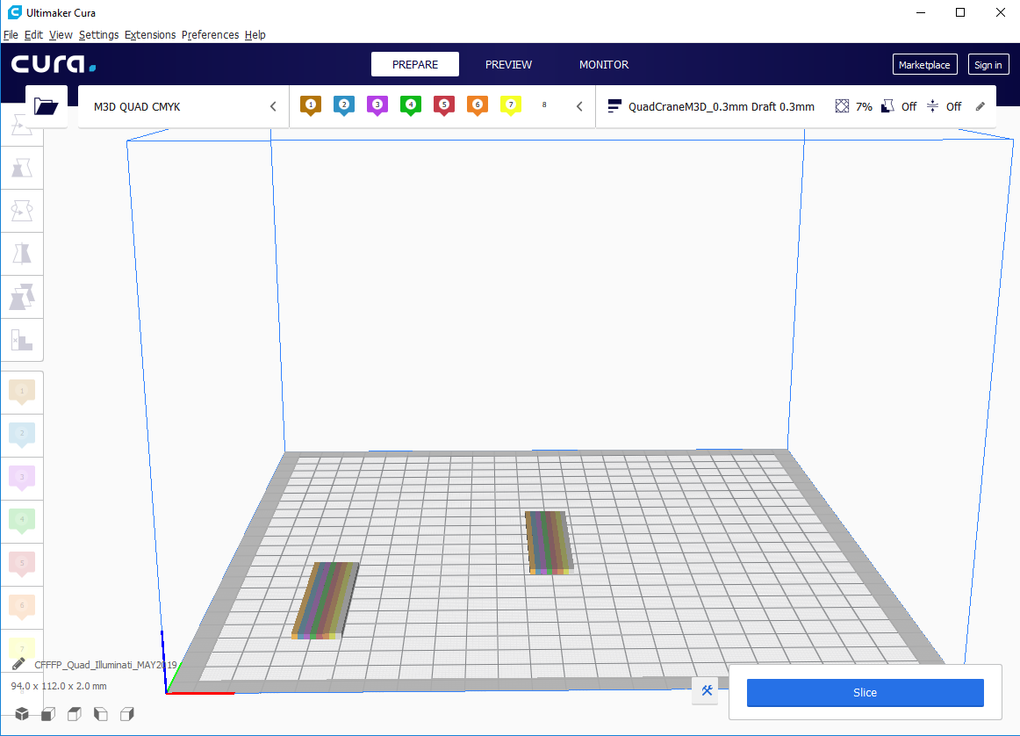

This includes a model of a 2 waste blocks. The lower left block will print its color first, then move on to the same color in the middle model so the middle model will have a true color.

On top you will see the printer name, the materials being used, and the profile information holding the settings.

Congratulations. Cura now is set up to use 8 different tools so can print in 8 colors!

Note: You may create your own custom materials to make a completely accurate representation of the materials and colors, but for our purpose we are trying to just get a representative color so we can preview what the our model will look like in Cura before actually printing it out. We will be later printing out at a fixed temperature, so the material selections here really do not matter.

**Step 4: Installing the Illuminati Mixer**

While all may seem well in Cura, this slicer needs some extra information to print with the M3D Quad Fusion Head. We have assigned 8 extruders in Cura, and we need to translate the instructions in the GCODE that Cura will produce to instructions the quad fusion printhead will be able to understand.

To install the plugin go to <https://github.com/ketterrm/Illuminati-Mixer> . Click on the download button and down load the zip.

Extract the zip and move the TwoEyedIlluminati.py to the C:\Program Files\Ultimaker Cura 4.0\plugins\PostProcessingPlugin\scripts. Restart Cura.

From the Cura menu select Extensions -> Post Processing -> Modify G-Code

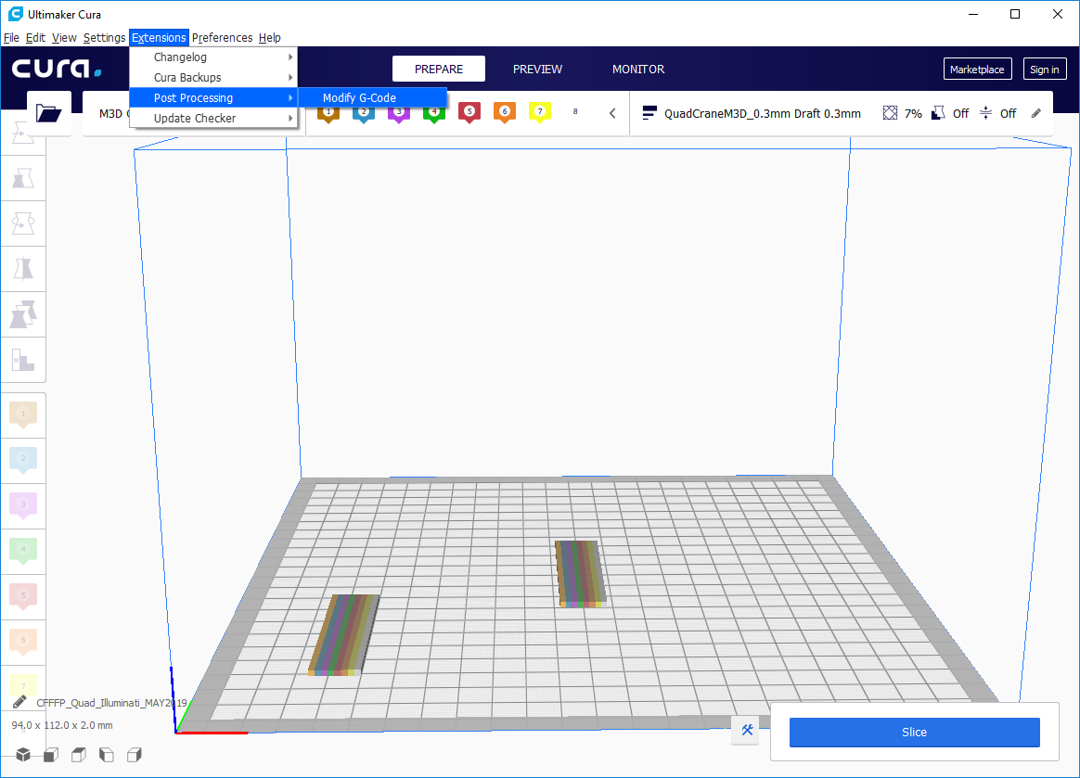

Click Add a script and select the Illuminati Mixer.

The Illuminati Mixer allows 8 custom mixtures to be defined in terms of a proportion of each of the CMKY filaments.

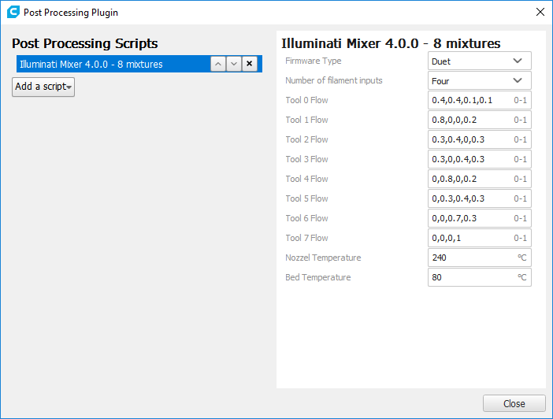

Each of the Tools are defined to represent the portion of flow from each of the 4 Quad Fusion Extractor Trains. For example, tool 0 by default is pulling from all the extruders and will result in a darker brown. The sum of the 4 numbers needs to add to 1.

Temperatures generated by Cura are all overwritten to a single temperature as specified in the plug in. While most multi extruder printers that have multiple physical nozzles have different temperatures, we are ensuring that there is only one temperature in the current release. All temperatures that are generated by Cura are commented out when running the plug in.

The plug-in will define a tool for each of the colors using M563 command. Cura generates tool changes well, so when the tool is switched, the color will switch.

Colors are changed using an M567 command based on the values provided in the plugin dialog.

**Step 5: Get ready to Print**

The default object on the build plate is something small to test with.

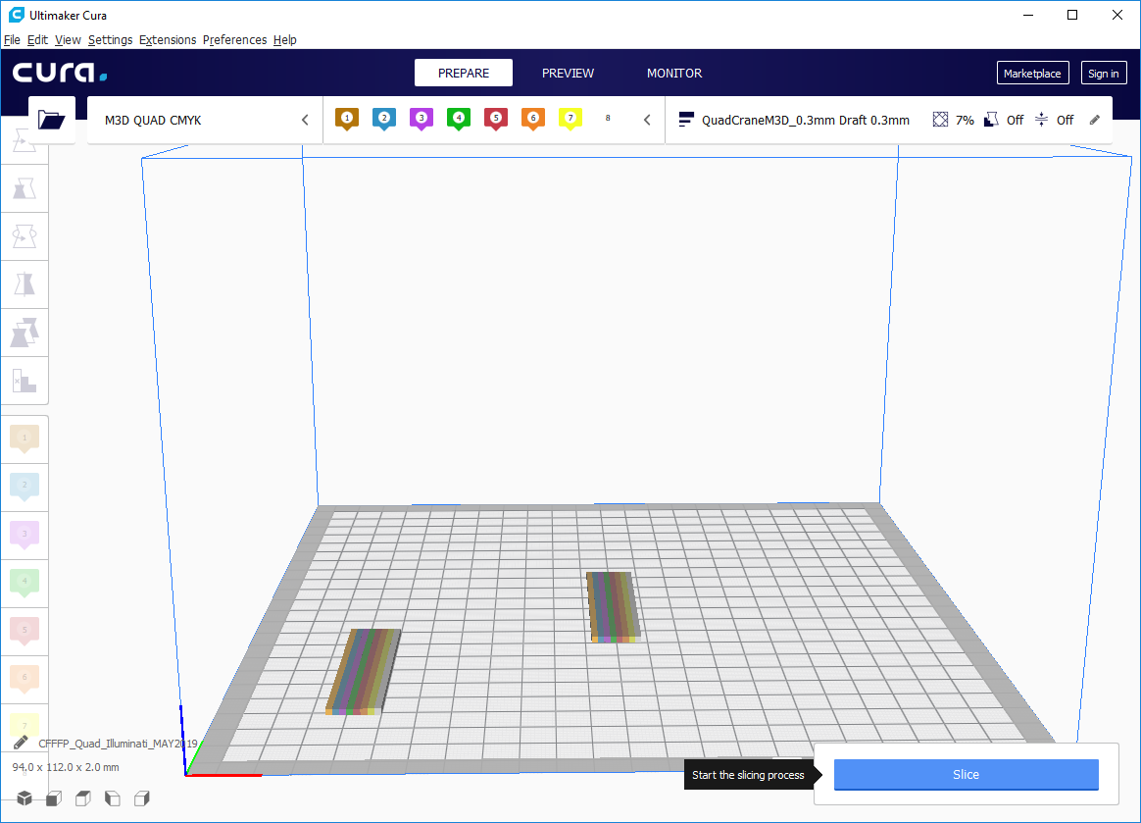

Now that the plugin is on Click the Slice button to generate the GCODE.

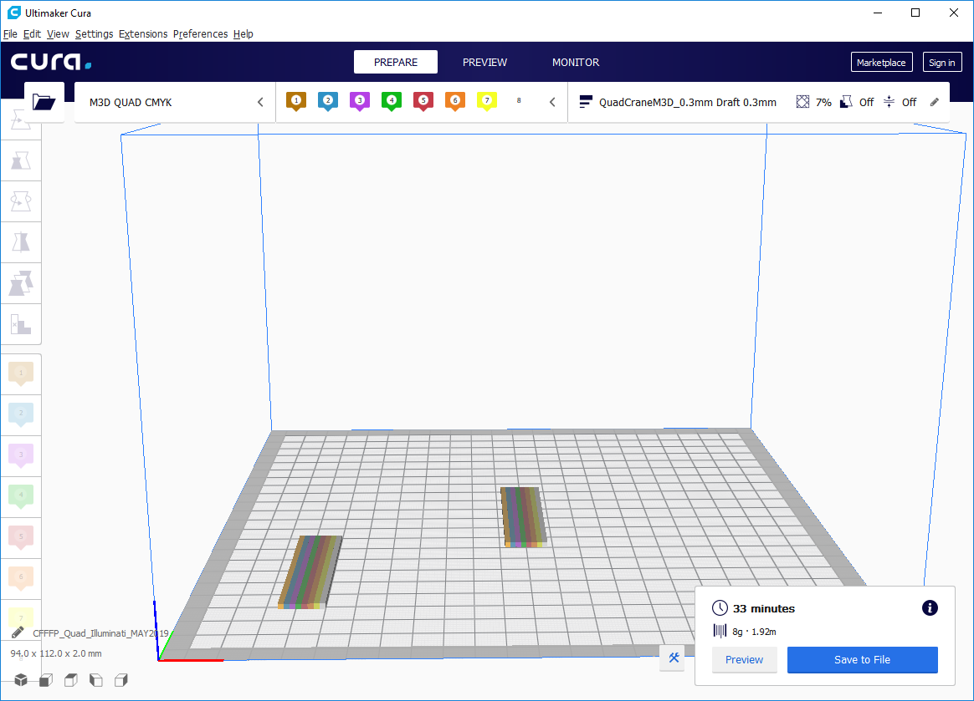

Click preview to preview the sliced file.

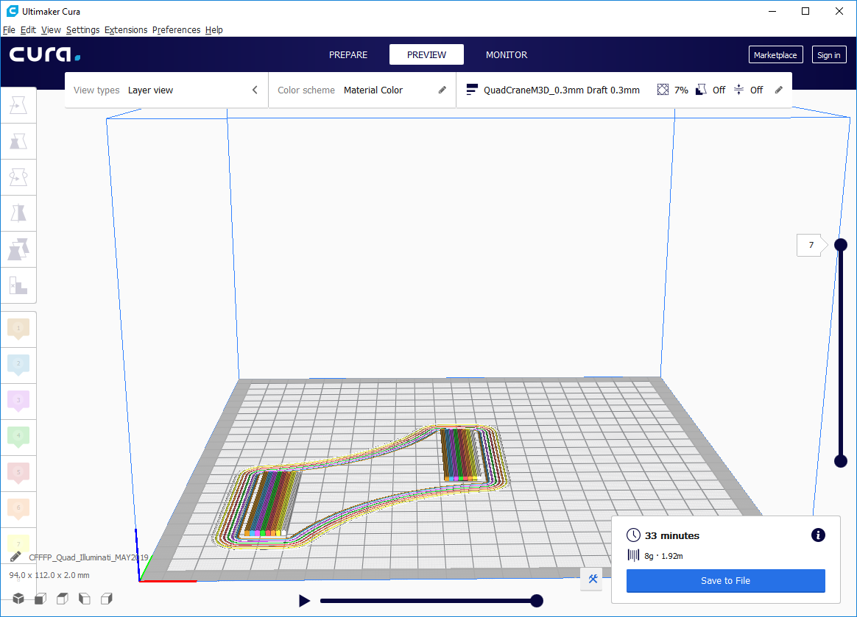

Use the Slider bars to see each layer and simulate.

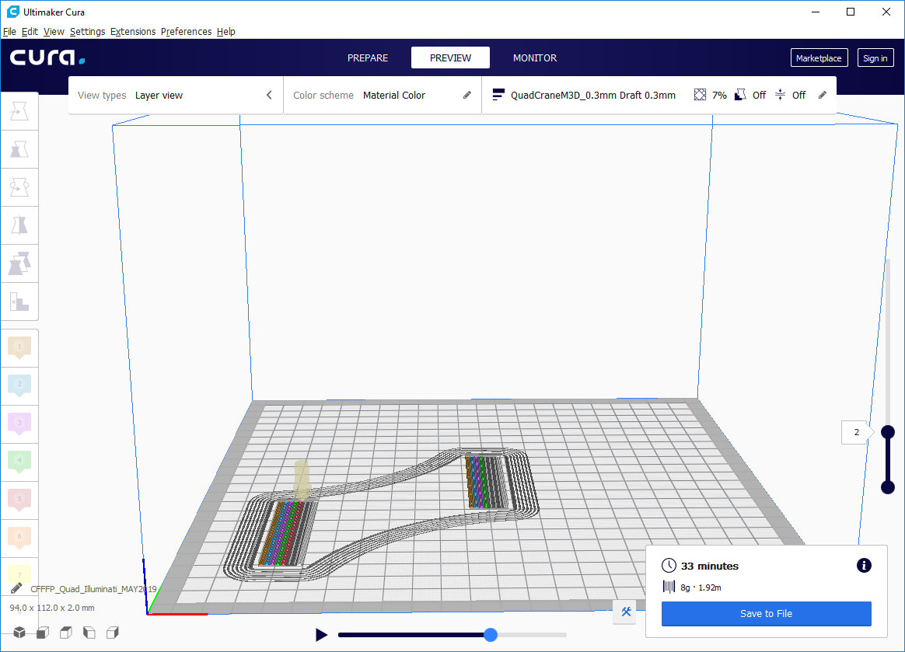

When you are satisfied, Click SAVE to File. You are ready to Print.

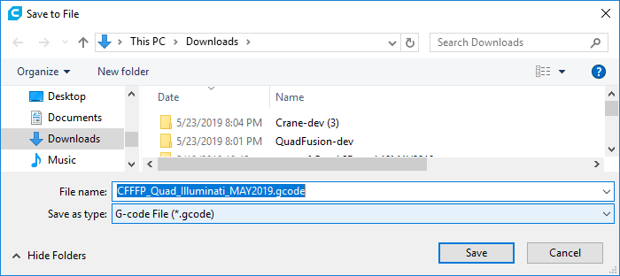

**Printing the file to the Quad.**

Load the quad with the CMYK filament. The default mixes are assuming you are using the transparent PETG for colors, and a white opaque for the key.

Drag and drop the file CFFFP_Quad_Illuminati_MAY2019.gcode file to the Duet web console’s “upload and start” button and ( note – the file is .gcode not .3mf)

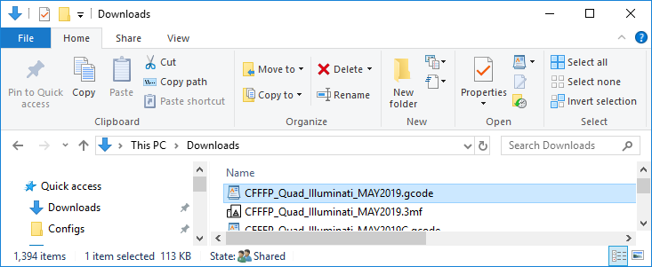

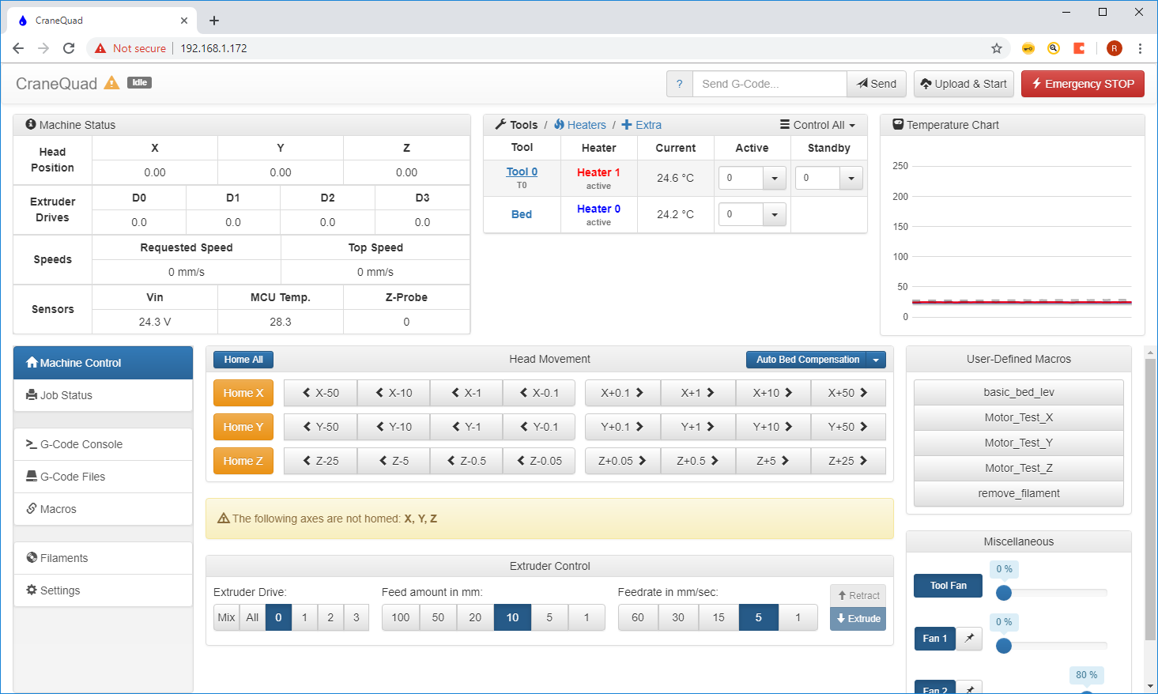

When starting the tools 0-7 will be added to the DWC as they are defined in the G code.

If the drag and drop does not work, you can also go to G-code files and select “Upload G code files”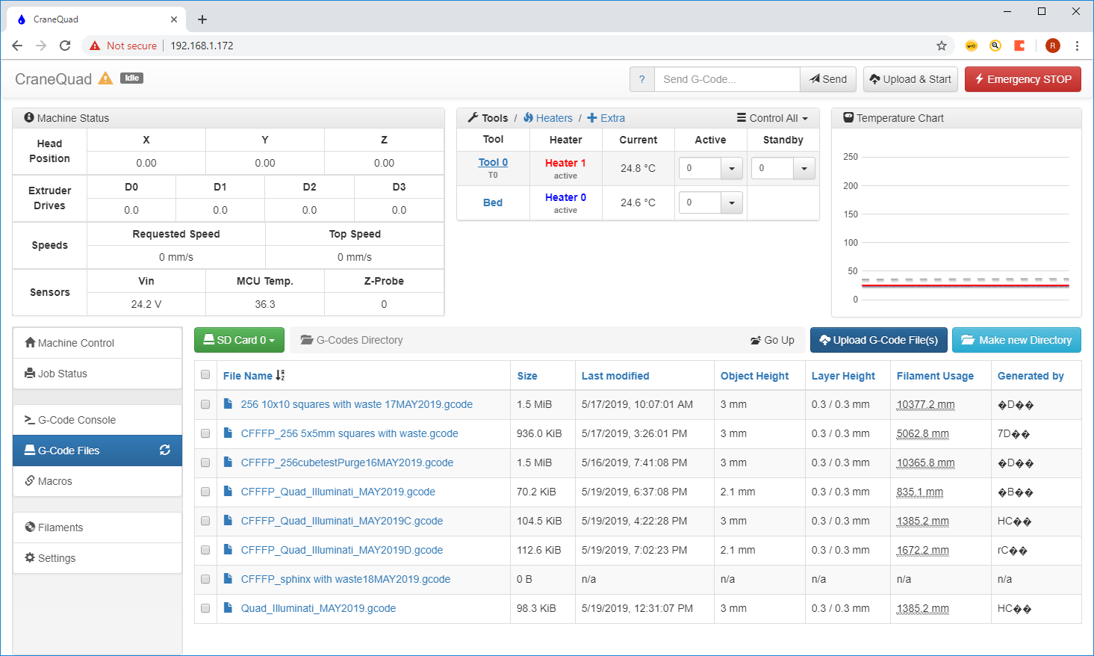

**TIPS:**

Note: It is a good idea to preheat the bed and nozzle before your start. When a tool is changed it will wait until the temperature is within a degree of the extruder temp to continue with the next tool. So getting the tool to be at a constant temp will help from having the print stall.

Custom Prime Tower – When colors switch, there is some transition between moving between colors. To get a clean color, we suggest you use a prime tower. Cura prime tower options are not ready for using more than 2 extruders at this time. The suggestion is to add your own Prime tower where you can control how large it is and how high it will go. By adding a prime tower onto the build plate before constructing and coloring your model, Cura has been consistently going to the prime tower first before the main model. Check this in your simulation before printing.

Using the merge process as was outlined for creating a model, you can create your custom prime tower to minimize wasted filament. Just as modeling your print is important, modeling a good prime tower will help save filament.

Updating settings in Cura. Note that each of the 8 extractors can have different settings. So if you change the speed of one of the extruders you need to change is for all if you want it to be global. When making a custom setting change you can right click and select to make the setting applicable to all extruders. Don’t be fooled to think that just because you changed the setting in one tool that it is applicable to the other 7!

**Step 3: Time to Color!**

First delete the sample model by right clicking on it and selecting “Delete Selected Model”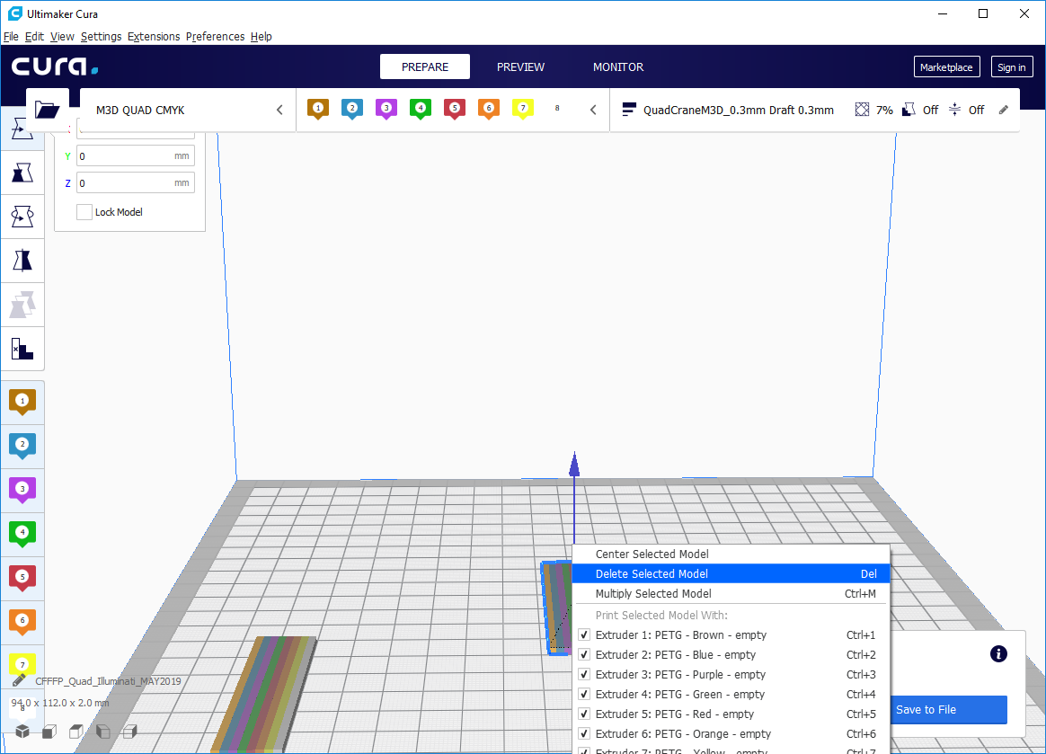

Keep the purge block if you want perfectly clean transitions.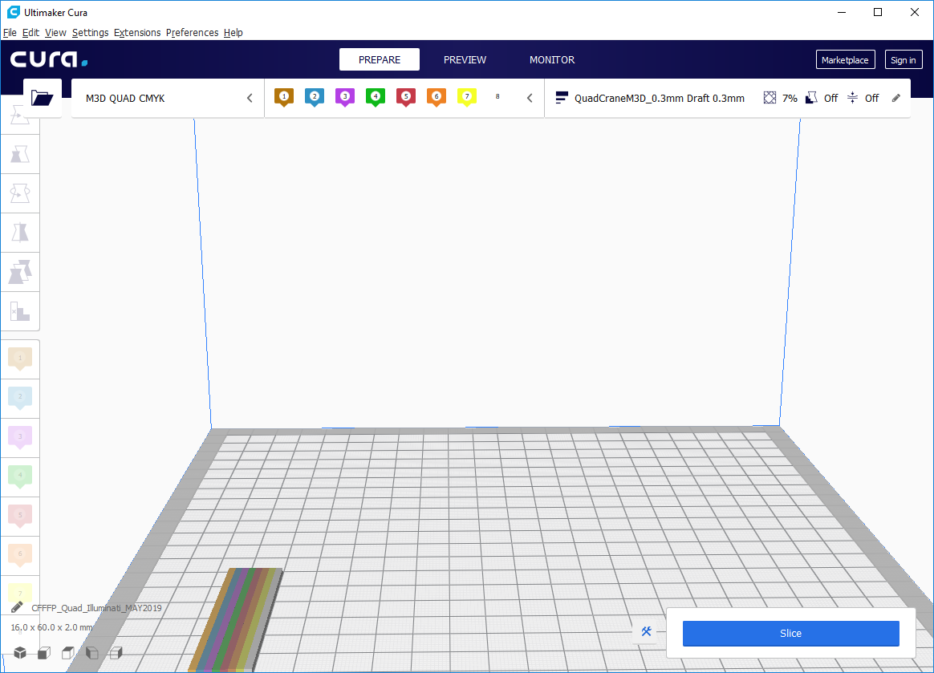

In Cura, load a model that contains multiple .stl files. There are many examples available from public sites such as thingverse. [www.thingverse.com](http://www.thingverse.com) . Searching “multi color” will provide many opportunities to color already existing models.

We will use a globe model as an example

<https://www.thingiverse.com/thing:2242946>

Select download all files.

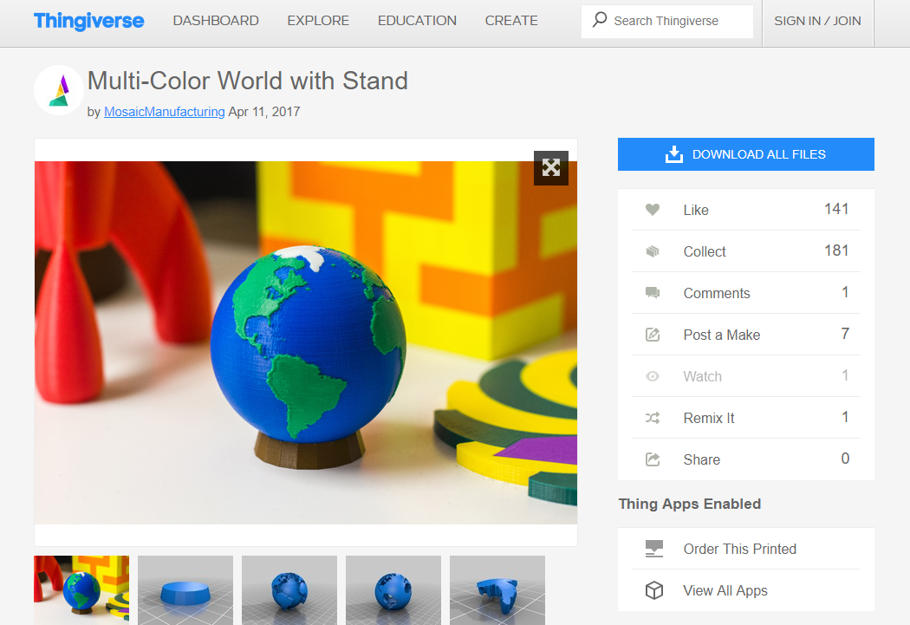

Click extract all:

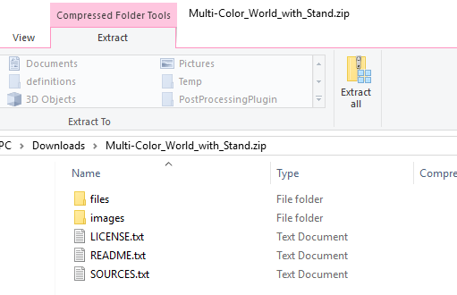

In CURA, Select Open and open all 4 .stl files :

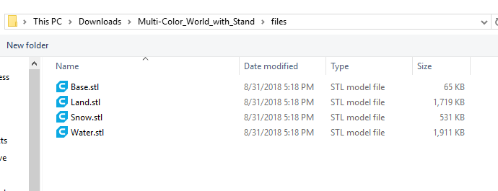

The 4 files will now appear on the build plate:

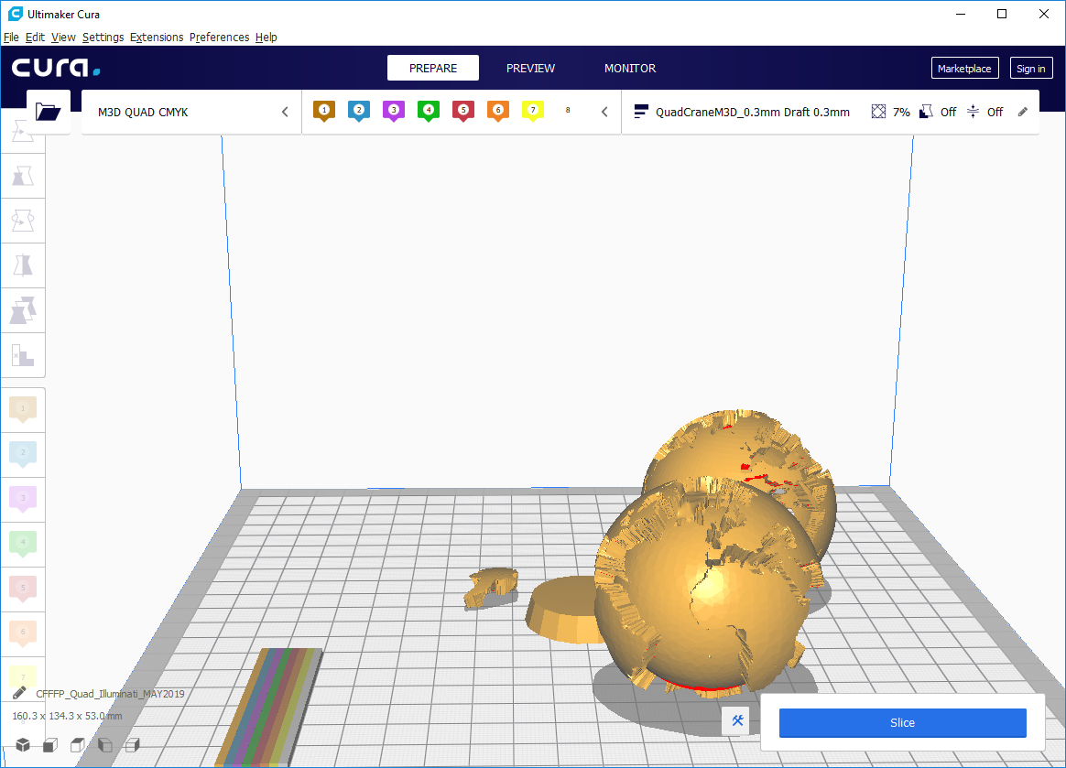

Lets put this together first before coloring.

Select all the parts by selecting holding shift and cliking the 4 parts..

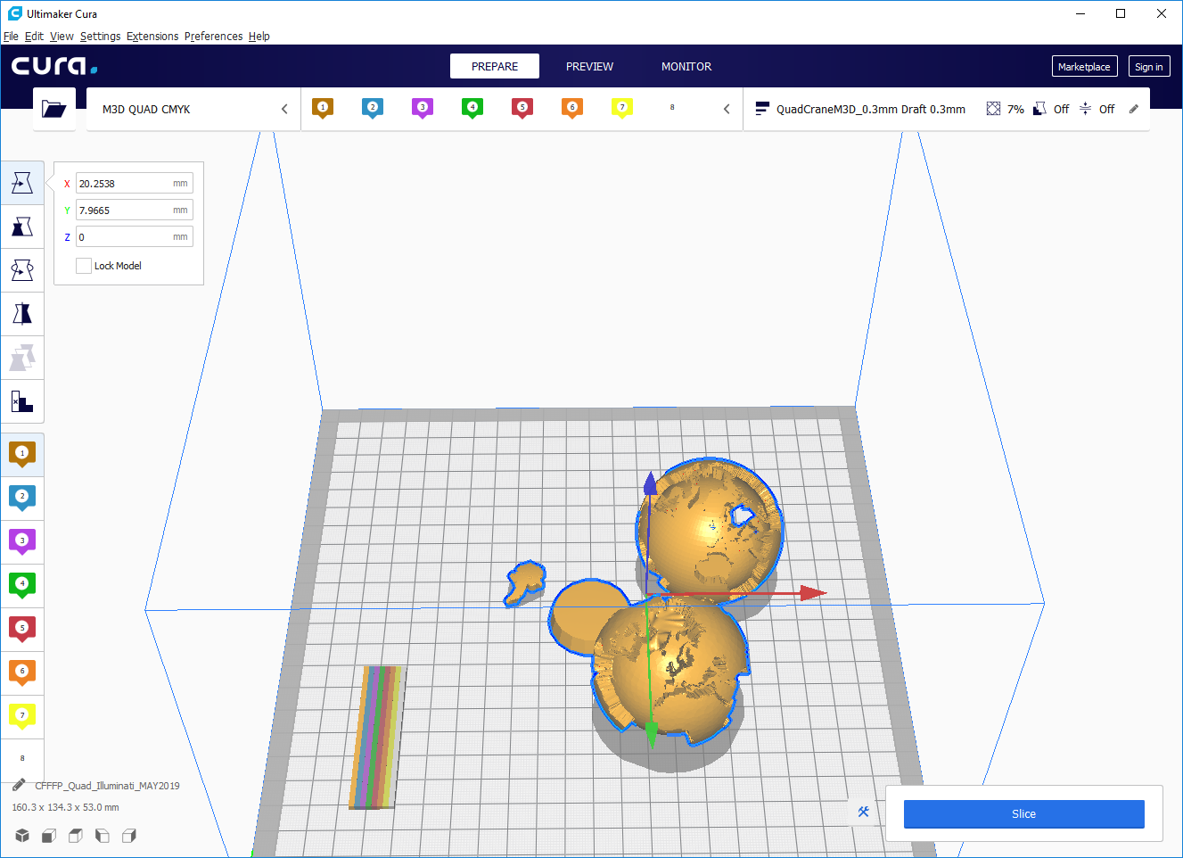

In the edit menu select merge models:

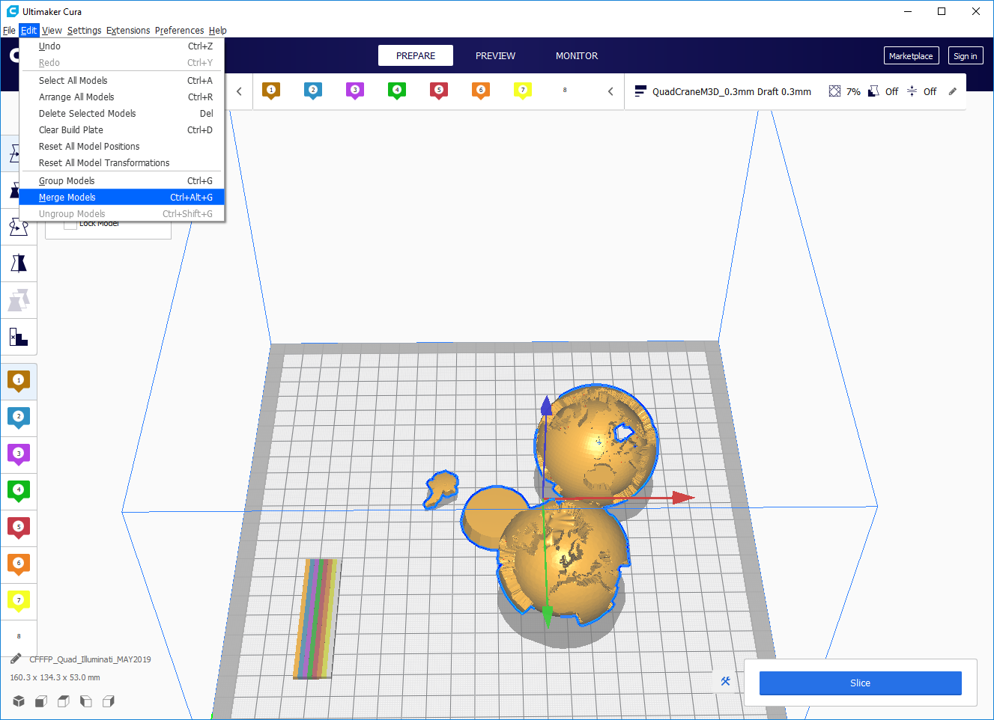

Now the model is put together.

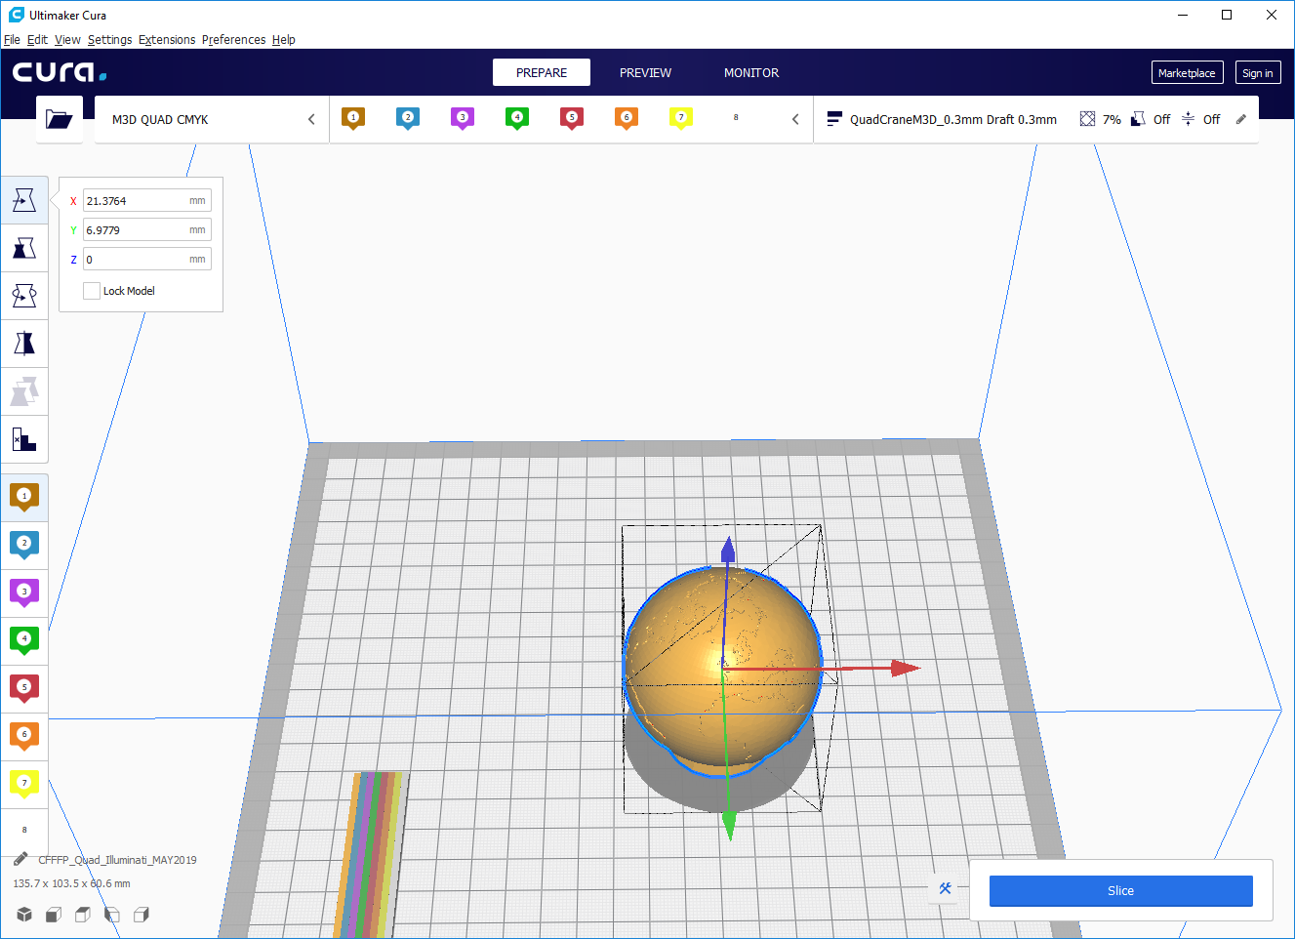

Select the land by holding CTRL and left click the land to select just this part of the merged stl files. Click the desired extruder on the left side tool to color. Continue to color the rest of the model using the same process.

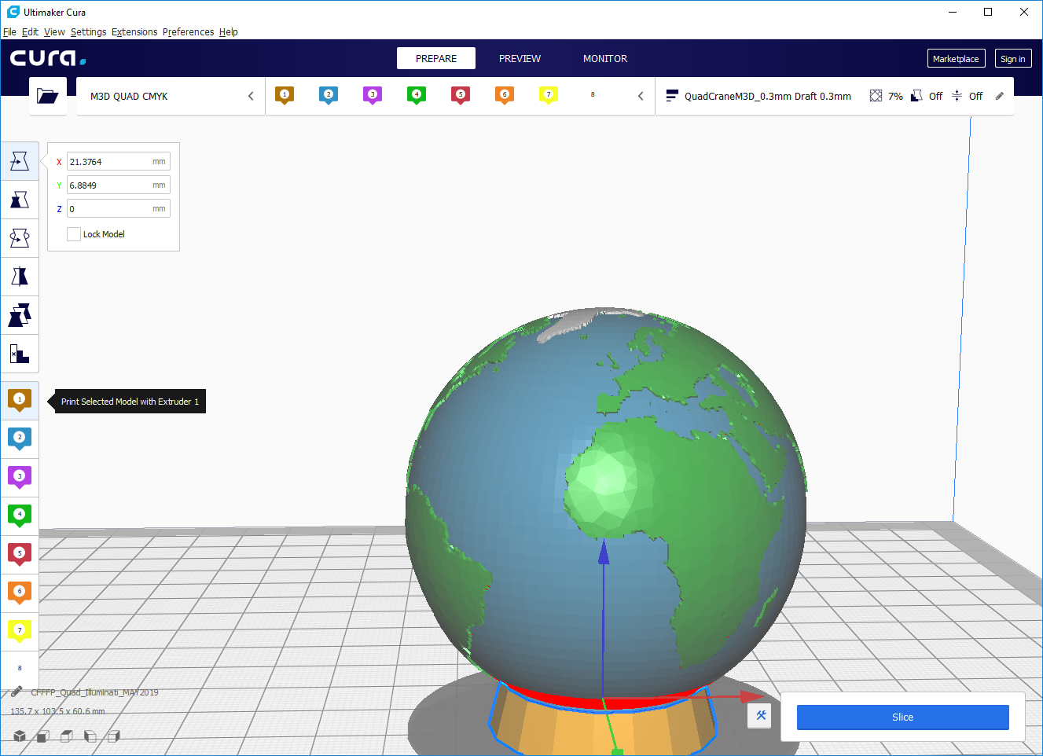

Congratulations. You now can color.